ATmega2560-Arduino Pin Mapping
Below is the pin mapping for the Atmega2560. The chip used in Arduino 2560. There are pin mappings to Atmega8 and Atmega 168/328 as well.
Arduino Mega 2560 PIN diagram
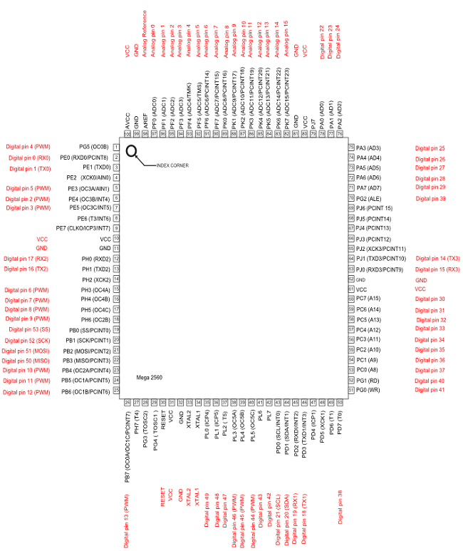
The source SVG file is also available for download: PinMapping2560.zip
Arduino Mega 2560 PIN mapping table
Pin Number | Pin Name | Mapped Pin Name
1 | PG5 ( OC0B ) | Digital pin 4 (PWM)
2 | PE0 ( RXD0/PCINT8 ) | Digital pin 0 (RX0)
3 | PE1 ( TXD0 ) | Digital pin 1 (TX0)
4 | PE2 ( XCK0/AIN0 )
5 | PE3 ( OC3A/AIN1 ) | Digital pin 5 (PWM)
6 | PE4 ( OC3B/INT4 ) | Digital pin 2 (PWM)
7 | PE5 ( OC3C/INT5 ) | Digital pin 3 (PWM)
8 | PE6 ( T3/INT6 )
9 | PE7 ( CLKO/ICP3/INT7 )
10 | VCC | VCC
11 | GND | GND
12 | PH0 ( RXD2 ) | Digital pin 17 (RX2)
13 | PH1 ( TXD2 ) | Digital pin 16 (TX2)
14 | PH2 ( XCK2 )
15 | PH3 ( OC4A ) | Digital pin 6 (PWM)
16 | PH4 ( OC4B ) | Digital pin 7 (PWM)
17 | PH5 ( OC4C ) | Digital pin 8 (PWM)
18 | PH6 ( OC2B ) | Digital pin 9 (PWM)
19 | PB0 ( SS/PCINT0 ) | Digital pin 53 (SS)
20 | PB1 ( SCK/PCINT1 ) | Digital pin 52 (SCK)
21 | PB2 ( MOSI/PCINT2 ) | Digital pin 51 (MOSI)
22 | PB3 ( MISO/PCINT3 ) | Digital pin 50 (MISO)
23 | PB4 ( OC2A/PCINT4 ) | Digital pin 10 (PWM)
24 | PB5 ( OC1A/PCINT5 ) | Digital pin 11 (PWM)
25 | PB6 ( OC1B/PCINT6 ) | Digital pin 12 (PWM)
26 | PB7 ( OC0A/OC1C/PCINT7 ) | Digital pin 13 (PWM)
27 | PH7 ( T4 )
28 | PG3 ( TOSC2 )
29 | PG4 ( TOSC1 )
30 | RESET | RESET
31 | VCC | VCC
32 | GND | GND
33 | XTAL2 | XTAL2
34 | XTAL1 | XTAL1
35 | PL0 ( ICP4 ) | Digital pin 49
36 | PL1 ( ICP5 ) | Digital pin 48
37 | PL2 ( T5 ) | Digital pin 47
38 | PL3 ( OC5A ) | Digital pin 46 (PWM)
39 | PL4 ( OC5B ) | Digital pin 45 (PWM)
40 | PL5 ( OC5C ) | Digital pin 44 (PWM)
41 | PL6 | Digital pin 43
42 | PL7 | Digital pin 42
43 | PD0 ( SCL/INT0 ) | Digital pin 21 (SCL)
44 | PD1 ( SDA/INT1 ) | Digital pin 20 (SDA)
45 | PD2 ( RXDI/INT2 ) | Digital pin 19 (RX1)
46 | PD3 ( TXD1/INT3 ) | Digital pin 18 (TX1)
47 | PD4 ( ICP1 )
48 | PD5 ( XCK1 )
49 | PD6 ( T1 )
50 | PD7 ( T0 ) | Digital pin 38
51 | PG0 ( WR ) | Digital pin 41
52 | PG1 ( RD ) | Digital pin 40
53 | PC0 ( A8 ) | Digital pin 37
54 | PC1 ( A9 ) | Digital pin 36
55 | PC2 ( A10 ) | Digital pin 35
56 | PC3 ( A11 ) | Digital pin 34
57 | PC4 ( A12 ) | Digital pin 33
58 | PC5 ( A13 ) | Digital pin 32
59 | PC6 ( A14 ) | Digital pin 31
60 | PC7 ( A15 ) | Digital pin 30
61 | VCC | VCC
62 | GND | GND
63 | PJ0 ( RXD3/PCINT9 ) | Digital pin 15 (RX3)
64 | PJ1 ( TXD3/PCINT10 ) | Digital pin 14 (TX3)
65 | PJ2 ( XCK3/PCINT11 )
66 | PJ3 ( PCINT12 )
67 | PJ4 ( PCINT13 )
68 | PJ5 ( PCINT14 )
69 | PJ6 ( PCINT 15 )
70 | PG2 ( ALE ) | Digital pin 39
71 | PA7 ( AD7 ) | Digital pin 29
72 | PA6 ( AD6 ) | Digital pin 28
73 | PA5 ( AD5 ) | Digital pin 27
74 | PA4 ( AD4 ) | Digital pin 26
75 | PA3 ( AD3 ) | Digital pin 25
76 | PA2 ( AD2 ) | Digital pin 24
77 | PA1 ( AD1 ) | Digital pin 23
78 | PA0 ( AD0 ) | Digital pin 22
79 | PJ7
80 | VCC | VCC
81 | GND | GND
82 | PK7 ( ADC15/PCINT23 ) | Analog pin 15
83 | PK6 ( ADC14/PCINT22 ) | Analog pin 14
84 | PK5 ( ADC13/PCINT21 ) | Analog pin 13
85 | PK4 ( ADC12/PCINT20 ) | Analog pin 12
86 | PK3 ( ADC11/PCINT19 ) | Analog pin 11
87 | PK2 ( ADC10/PCINT18 ) | Analog pin 10
88 | PK1 ( ADC9/PCINT17 ) | Analog pin 9
89 | PK0 ( ADC8/PCINT16 ) | Analog pin 8
90 | PF7 ( ADC7 ) | Analog pin 7
91 | PF6 ( ADC6 ) | Analog pin 6
92 | PF5 ( ADC5/TMS ) | Analog pin 5
93 | PF4 ( ADC4/TMK ) | Analog pin 4
94 | PF3 ( ADC3 ) | Analog pin 3
95 | PF2 ( ADC2 ) | Analog pin 2
96 | PF1 ( ADC1 ) | Analog pin 1
97 | PF0 ( ADC0 ) | Analog pin 0
98 | AREF | Analog Reference
99 | GND | GND
100 | AVCC | VCC

